**Deploying jar**

##### **Step 1: Goto the directory**

# cd /home/ubuntu/https-github.com-g0t4-jenkins2-course-spring-boot/spring-boot-samples/spring-boot-sample-web-static/target

**Step 2 :**

# java -jar spring-boot-sample-web-ui-1.4.0.BUILD-SNAPSHOT.jar &

##### **Step 3: Open new web browser tab and visit** [**http://52.15.125.49:8080/**](http://52.15.125.49:8080/) **( Piblicip:8080)**

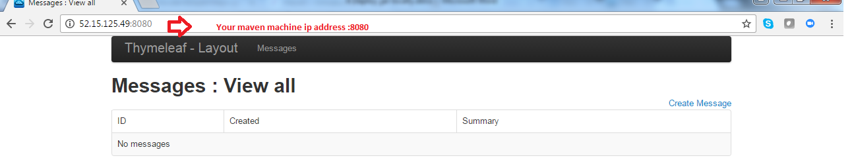

##### **Step 4 : cancel the service**

Ctrl c